BigDecimal v1.2 Add-in
Functional Understanding Document
Version 1.0

Table of Contents
1 Introduction 4
1.1 Why BigDecimal? 4
2 Installation of BigDecimal v1.2.xlam 4
2.1.1 Downloading the BigDecimal Add-in 4
2.1.2 Important: Unblocking the Add-in 5
3 Working with BigDecimal 6
3.1 Referencing BigDecimal in VBA 6
4 BigDecimal “Quick Start” Guide 6
4.1 Instantiating the BigDecimal Class 7
4.2 Implementation Example: Basic Addition 7
4.3 Language Limitations: Operator Overloading 8
5 Functional Specifications 8
5.1 BigDecimal Methods 8
5.2 BigDecimal Properties 9
5.2.1 Effortless Precision with Auto-Trimming 10
5.2.2 Mutable vs. Immutable Properties 10
6 Conclusion 11

List of Tables
Table 5-1:BigDecimal Methods 9
Table 5-2: BigDecimal Properties 10

List of Figures
Figure 2-1: Excel Add-ins Folder 5
Figure 2-2: Unblock Downloaded BigDecimal Add-in 5
Figure 3-1: Adding BigDecimal_v1_2 as a Reference 6

Introduction
Welcome to BigDecimal, a a high-performance, arbitrary-precision decimal library designed to break the 15-digit precision barrier of standard Excel calculations. Heavily inspired by the robust BigDecimal implementations found in enterprise languages like Java, this add-in brings industrial-grade numerical accuracy directly to your spreadsheets.
Whether you are performing complex financial reconciliations or deep scientific research, BigDecimal ensures that your results are never compromised by floating-point errors or rounding limitations.

Why BigDecimal?
Standard Excel uses the IEEE 754 floating-point standard, which is excellent for speed but can introduce "silent" errors in very large or very small numbers. BigDecimal for Excel replaces this with an exact-value representation, allowing you to define the exact scale and precision required for your specific use case.

Installation of BigDecimal v1.2.xlam
Follow the steps below to install the BigDecimal add-in and integrate it with Microsoft Excel. These steps ensure the library is correctly registered and available for use within the VBA Editor.

Downloading the BigDecimal Add-in
To install the Add-in, download the BigDecimal v1.2.xlam file from the GitHub repository and move it to the local Microsoft Add-ins directory:

C:\Users\[YourUsername]\AppData\Roaming\Microsoft\AddIns

Note: Replace [YourUsername] with your active Windows login name.

Quick Access Shortcut:
Alternatively, you can access this folder directly by pasting the following environment variable into the File Explorer address bar:

%appdata%\Microsoft\AddIns

Once the folder is open, drag and drop the BigDecimal v1.2.xlam file from your Downloads folder into the Addins folder as in Figure 2-1.

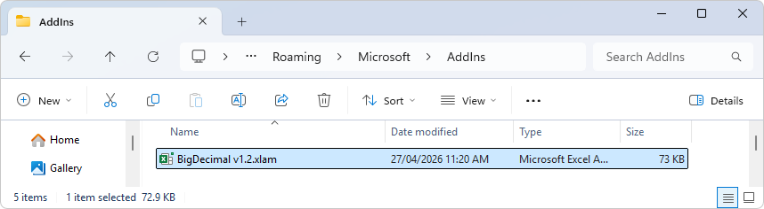
Figure 2-1: Excel Add-ins Folder

Important: Unblocking the Add-in
Because the file was downloaded from an external source (GitHub), Windows will apply a 'Mark of the Web' security attribute, which prevents the Add-in from executing macros. Even if the file is placed in the correct directory, it will not function until it is manually unblocked.

To unblock the Add-in:
- Navigate to the %appdata%\Microsoft\AddIns folder
- Right-click the BigDecimal v1.2.xlam file.
- Select Properties.
- At the bottom of the General tab, look for Security.
- Check the Unblock box and click Apply.

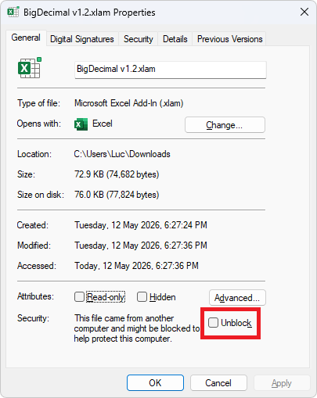
Figure 2-2: Unblock Downloaded BigDecimal Add-in

Working with BigDecimal
Before the BigDecimal class can be utilized in your VBA project, it must be properly initialized within the VBA environment. This involves linking the Add-in to your specific workbook and ensuring the VBA compiler can access the library’s properties and methods.

Referencing BigDecimal in VBA
Once the Add-in is installed and unblocked, you must establish a reference to the library within your specific VBA Project. This allows the VBA compiler to recognize the BigDecimal class and provide IntelliSense support while coding.

Follow these steps to enable the reference:
- Open Excel.
- Go to the Developer tab (If you don't see it, right-click any ribbon tab > Customize the Ribbon > Check "Developer").
- Click View Code.
- Go to the Tools menu > References.. and locate BigDecimal_v1_2 and select it as in Figure 3-1. A tick mark will appear next to BigDecimal_v1_2.
- Click OK.

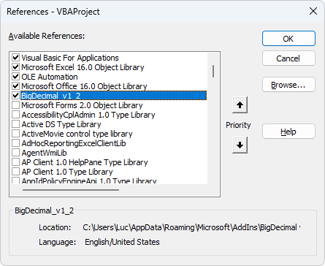
Figure 3-1: Adding BigDecimal_v1_2 as a Reference

At this stage the add-in is now available to use in your VBA Project.

BigDecimal “Quick Start” Guide
BigDecimal is designed to work seamlessly within the Excel environment, its implementation respects the standard VBA architectural patterns used by Microsoft Office. To ensure maximum compatibility and performance across different workbooks, the library utilizes a controlled instantiation model. This approach prevents common reference errors and ensures that every BigDecimal object is correctly initialized with the high-precision engine.

Instantiating the BigDecimal Class
In standard object-oriented programming, you would typically instantiate a class using the New keyword. However, due to the PublicNotCreatable nature of classes within an Excel Add-in environment, the BigDecimal class cannot be created directly by external projects.
To bypass this limitation, the Add-in provides a global factory function: New_BigDecimal(). This function serves as the entry point for object creation, allowing you to initialize a new BigDecimal instance. It optionally accepts a string parameter to set the initial value of the number, ensuring precision is maintained from the moment of instantiation.

Public Function New_BigDecimal(Optional StrValue As String = "") As BigDecimal

Implementation Example: Basic Addition
The following example, adapted from the BigCalculator source code, demonstrates how to instantiate two BigDecimal objects from user input, perform basic validation, and output the result of an addition operation.

Private Sub Add_Click()
Dim Num1 As BigDecimal
Dim Num2 As BigDecimal

With BigDecimalForm
' Instantiate objects using the New_BigDecimal factory function
Set Num1 = New_BigDecimal(.Num1.Value)
Set Num2 = New_BigDecimal(.Num2.Value)

' Validate inputs and check for successful instantiation
If .Num1.Value = "" Then
ErrBox "Number 1 is empty!", "Input Error"
Exit Sub
ElseIf .Num2.Value = "" Then
ErrBox "Number 2 is empty!", "Input Error"
Exit Sub
ElseIf Num1 Is Nothing Then
ErrBox "Number 1 is invalid!", "Validation Error"
Exit Sub
ElseIf Num2 Is Nothing Then
ErrBox "Number 2 is invalid!", "Validation Error"
Exit Sub
End If

' Perform addition and return the result as a string
.Answer.Value = Num1.Add(Num2).StrValue
End With
End Sub

Language Limitations: Operator Overloading
A notable constraint of the VBA environment is the lack of Operator Overloading. In many modern languages, you can redefine standard operators (such as +, -, *, or /) to work directly with custom classes. Ideally, one would use a syntax like Set Result = Num1 + Num2; however, this is not supported in VBA.

Consequently, there is no direct workaround for this language limitation. All arithmetic operations must be performed by calling the explicit methods of the BigDecimal class. While this requires a slightly more verbose coding style, the method names are intuitive and follow standard mathematical naming conventions.

Functional Specifications
This section provides a detailed technical breakdown of the public classes, methods, and properties that comprise the BigDecimal framework. These components form the core engine of the library, enabling the programmatic initialization of high-precision variables, the execution of complex mathematical operations, and the fine-tuning of calculation parameters such as scale and rounding. By leveraging these members, developers can extend the numerical capabilities of their Excel applications far beyond the standard limits of floating-point arithmetic.

BigDecimal Methods
The following table outlines the comprehensive suite of arithmetic and utility methods supported by the BigDecimal class, designed to provide consistent results for high-precision computational tasks.

Method | VBA Syntax (BigDecimal) | Notes
Add | Num1.Add(Num2) | Returns the sum of Num1 and Num2.
Subtract | Num1.Subtract(Num2) | Returns the difference (Num1 - Num2).
Multiply | Num1.Multiply(Num2) | Returns the product of Num1 and Num2.
Divide | Num1.Divide(Num2) | Returns the quotient; precision depends on settings.
Modulus | Num1.Modulus(Num2) | Returns the remainder of the division.
SquareRoot | Num1.SquareRoot() | Calculates the square root to current precision.
Logarithm | Num1.Logarithm() | Calculates the Natural Logarithm (ln).
Exponential | Num1.Exponential() | Calculates the Natural Exponent (e^x).
Factorial | Num1.Factorial() | Calculates the product of all positive integers.
Absolute | Num1.Abs() | Returns the absolute (non-negative) value.
Negative | Num1.Negative() | Returns the value multiplied by -1.
Whole | Num1.Whole() | Returns the integer part without rounding.
Fraction | Num1.Fractional() | Returns only the decimal/fractional part.
Round | Num1.Round(Scale) | Rounds to a specified number of decimal places.
Trim | Num1.Trim() | Trim leading and trailing 0
Compare | Num1.Compare(Num2) | Returns -1 (less), 0 (equal), or 1 (greater).
Table 5-1:BigDecimal Methods

BigDecimal Properties
The BigDecimal class includes a set of public properties that provide critical insights into the state and value of your numerical objects. Unlike standard numeric types in VBA, which require complex parsing to analyze, these properties allow you to directly access the internal characteristics of a number—such as its string representation, its current scale (the number of digits after the decimal point), and its sign. By utilizing these properties, developers can easily integrate high-precision results into the Excel UI or use them as conditional logic in complex financial and scientific algorithms.

Property | Access | Notes
.Value | Read/Write | Gets or sets the BigDecimal object itself.
.StrValue | Read/Write | Gets or sets the value via a String. Ideal for updating the object from a TextBox.
.LngValue | Read/Write | Gets or sets the value via a Long. Overwrites the object with a whole number.
.DblValue | Read/Write | Gets or sets the value via a Double. Useful for quick conversion from standard variables.
.MaxScale | Read/Write | Gets or sets the number of decimal places. Setting this can truncate or pad the number.
.Pi | Read Only | Returns the constant Pi as a high-precision BigDecimal object.
Table 5-2: BigDecimal Properties

Effortless Precision with Auto-Trimming
The BigDecimal class is designed to deliver clean, professional output without the need for manual string manipulation. While the internal object may retain leading and trailing zeros to preserve the integrity of its data structure, the .StrValue property handles the cleanup for you. Every time you access the value via this property, the library automatically trims any non-significant zeros, ensuring your results are presented in their most concise and readable form while maintaining the high-precision accuracy you require.

Mutable vs. Immutable Properties
Most properties in the BigDecimal class are Mutable, meaning you can change the value of an existing object without needing to create a new one using the factory function.
- Direct Modification: By setting .StrValue or .DblValue, you can reuse an existing BigDecimal variable and update its internal data instantly.
- Precision Control: Manually setting the .Scale allows you to force a specific decimal length on an existing number, which is useful for formatting financial data (e.g., forcing 2 decimal places).
- The Pi Exception: Unlike the other properties, Pi is a constant. It cannot be overwritten, as it represents a fundamental mathematical value. Attempting to set Num1.Pi = 3 will result in a compilation error, ensuring the integrity of your geometric calculations.

Conclusion
Thank you for choosing BigDecimal.

The goal of this library is to provide a robust, high-precision numerical engine that bridges the gap between standard VBA data types and the rigorous accuracy required for modern financial and scientific applications.

I hope the current feature set—from the intelligent auto-trimming logic to the definitive precision control of MaxScale—empowers you to build more reliable and professional tools. As the development of this class continues, I am committed to maintaining this balance of mathematical integrity and developer-friendly flexibility.

